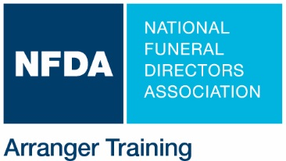
NFDA Only: Confirmed Training Date

Arrangement Skills Masterclass Host Form

Thank you for your organization’s interest in partnering with NFDA to host an NFDA Arranger Training seminar.

- Please complete, sign, and email this form to Lanae Strovers, lstrovers@nfda.org
- We will contact you to discuss what we can do together to bring this exclusive training program to your location.
- Minimum 15 registrants. Host receives reimbursement for each registrant based on total registrants. See page 2.
- Approved for up to 8 CE hours by APFSP and by most state and province funeral service licensing boards

This form MUST be returned at least 8 weeks prior to the proposed seminar date. Completion of this form signifies intent only and is not a seminar confirmation until host and NFDA agree to date and provisions. Please read pages 1 and 2. At such time as the host and NFDA agree to hold the seminar, the terms and conditions herein (pages 1 and 2) will be binding upon the host and NFDA.

Double click on check boxes to open.

Name of Host Organization
Primary Contact |  | Phone
Title |  | Email
Marketing Contact  (if different than primary contact) |  | Phone
Title |  | Email
Organization Address
City/State/Zip
Organization Website
1. | Proposed date of Training
2. | Estimated number of host registrants
3. | Is seminar restricted to host members or employees? | Yes Host members or employees only  No Open to all qualified registrants
4. | LOCATION of training
5. | Maximum CAPACITY of training room
6. | Training room setup options | Classroom Theatre Chevron Hollow U or Square
7. | AV provided by the host: | Projector, Screen, Audio connection for videos
8. | Food/Beverage Arrangements | Host will arrange for continental breakfast, lunch and beverages (soda, water and coffee.) NFDA will reimburse this cost per terms on page 2.
Primary Contact Signature

Electronic entry of this name satisfies the signature validity requirement of this form and acknowledges that the Primary Contact, on behalf
of the host organization, has read both pages 1 and 2 of this form and that the host organization agrees to terms and conditions herein.
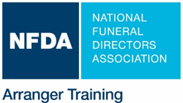

Hosting an NFDA Arrangement Skills Masterclass Is Easy!

The Host

- Receives revenue share based on registered licensed professionals as follows:
For each registrant up to 30, $50 each; for each additional registrant up to 50, $100 each. Please note: There is no reimbursement for registrants registered as apprentices or interns, faculty, students, or non-funeral directors.

Example for 40 registrants: $1500 (first 30 x $50) + $1000 (10 additional x $100) = total reimbursement of $2500 to host.

- Provides training room for the day of the seminar.
- Provides projector, screen, flip chart and audio connection.
- Assists with targeted promotion of the event via emails, newsletters, website, social media, etc. to local funeral service community and/or association members.
- Is reimbursed up to $40 per attending registrant for providing continental breakfast, lunch, and beverages. All food and beverage receipts must be submitted to NFDA within 30 days of program.

NFDA

- Covers all facilitator expenses.
- Provides 8 hours of training and follow up one-on-one coaching opportunity with facilitator.
- Executes comprehensive promotional campaign, including but not limited to:
  - targeted emails to potential registrants,
  - program listing on the NFDA website,
  - program listing in the weekly NFDA Bulletin and other NFDA publications, and
  - social media posts.
- Provides Host Success Toolkit with marketing collateral and tips for effective promotion.
- Ships training materials and copies of the NFDA Arranger Training Workbook to the site for each registrant.
- Facilitates registration and processing, CE approval application to state licensing board/s and post-event CE processing as required.

For more information, contact Lanae Strovers at lstrovers@nfda.org or 262.789.1880.

