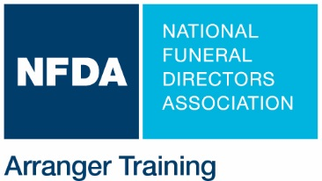
NFDA Only: Confirmed Training Date

Student Arranger Training Host Form

Thank you for your interest in partnering with NFDA to host an NFDA Student Arranger Training seminar at your school!

- Please complete, sign, and email this form to Lanae Strovers, lstrovers@nfda.org
- We will contact you to discuss what we can do together to bring this exclusive training program to your students.
- Minimum 15 students.
- Special Student Rate of $99.
- Approved for up to 4 CE hours (for faculty) by APFSP and by most state and province funeral service licensing boards

This form MUST be returned at least 8 weeks prior to the proposed seminar date. Completion of this form signifies intent only and is not a seminar confirmation until host and NFDA agree to date and provisions. Please read pages 1 and 2. At such time as the host and NFDA agree to hold the seminar, the terms and conditions herein (pages 1 and 2) will be binding upon the host and NFDA

Double click on check boxes to open.

Name of Host Organization
Primary Contact |  | Phone
Title |  | Email
Other Contact (if applicable) |  | Phone
Title |  | Email
Organization Address
Organization Website
Primary Billing Contact  (if different than host organization) |  | Phone
 |  | Email
Billing Address
1. | Proposed Date/s & Times |  |  |  | In-person  Virtual
2. | Number of Registrants  *The sponsor will be billed for the number of student attendees indicated in this agreement; if additional students attend, an additional invoice will be sent for the additional student registration fees. | Students* |  | Faculty
3 | LOCATION of Training
4 | AV provided by the host  (for in-person programs only) | Projector, screen, and audio connection for videos
Primary Contact Signature

Electronic entry of this name satisfies the signature validity requirement of this form and acknowledges that the Primary Contact, on behalf
of the host organization, has read both pages 1 and 2 of this form and that the host organization agrees to terms and conditions herein.

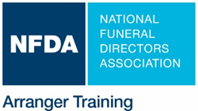

Hosting an NFDA Student Arranger Training Is Easy!

The Host

- Provides training room for the day of the seminar.
- Provides projector, screen, and audio connection.
- Assists with targeted promotion, as needed, of the event via emails, newsletters, website, social media, etc. to students.

NFDA

- Covers all facilitator expenses.
- Provides 4 hours of training and follow up one-on-one coaching opportunity with facilitator.
- Provides Host Success Toolkit with marketing collateral and tips for effective promotion.
- Ships training materials and copies of the NFDA Arranger Training Workbook to the site for each registrant.
- Facilitates registration and processing as well as CE approval application to state licensing board/s and post-event CE processing as required.

For more information, contact Lanae Strovers at lstrovers@nfda.org or 262.789-1880

